***Roll Number: 20SW013***

**Lab#01 - DS&A**

**Task 1**

***Write two lines of code below, each assigning a value to a variable # Now write a print statement using .format() to print out a sentence and the # values of both of the variables***

***CODE:***

variable_one = 15

variable_two = "Heylo, this is Sam Jeelani!"

print("The value of variable_one is {} and the value of variable_two is '{}'.".format(variable_one, variable_two))

***Output:***

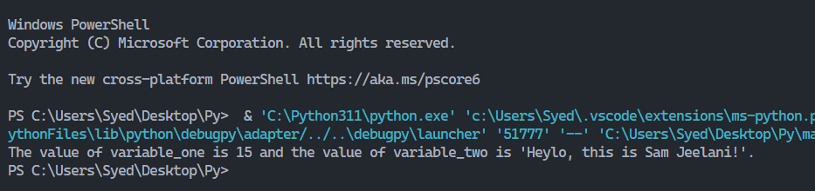

**Task 2**

***Browse the complete list of string methods at: # https://docs.python.org/3/library/stdtypes.html#string-methods # and try them out here***

***CODE:***

string = "Data Science!"

print(string.capitalize())

print(string.casefold())

print(string.center(15, "-"))

print(string.count("a"))

print(string.endswith("Science!"))

print(string.find("c"))

print(string.islower())

my_list = ["Data", "Science"]

print(",".join(my_list))

print(string.lower())

print(string.replace("a", "*"))

print(string.split(","))

print(string.strip("S!"))

print(string.swapcase())

***OUTPUT***

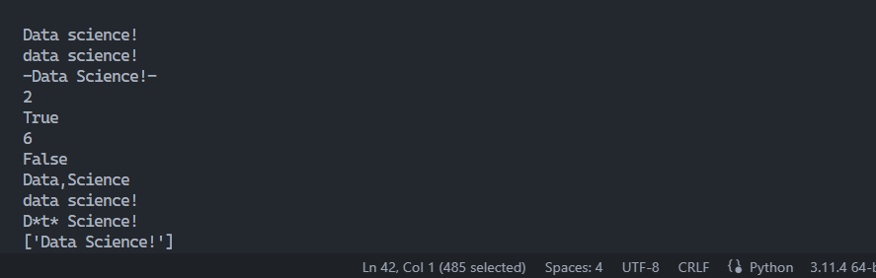

***Task 3***

List Indexing Use list indexing to determine how many days are in a particular month based on the integer variable month , and store that value in the integer variable num_days . For example, if month is 8, num_days should be set to 31, since the eighth month, August, has 31 days. Remember to account for zero-based indexing! month = 8 days_in_month = [31,28,31,30,31,30,31,31,30,31,30,31] # use list indexing to determine the number of days in month print(num_days)

***CODE***

month = 8

days_in_month = [31, 28, 31, 30, 31, 30, 31, 31, 30, 31, 30, 31]

num_days = days_in_month[month - 1]

print(num_days)

***OUTPUT***

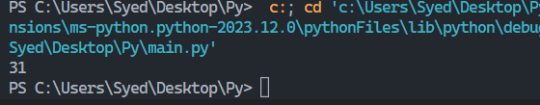

***Task 4***

***Select the three most recent dates from this list using list slicing notation. Hint: negative indexes work in slices! eclipse_dates = ['June 21, 2001', 'December 4, 2002', 'November 23, 2003', 'March 29, 2006', 'August 1, 2008', 'July 22, 2009', 'July 11, 2010', 'November 13, 2012', 'March 20, 2015', 'March 9, 2016'] # TODO: Modify this line so it prints the last three elements of the list print(eclipse_dates)***

***CODE***

eclipse_dates = ['June 21, 2001', 'December 4, 2002', 'November 23, 2003', 'March 29, 2006', 'August 1, 2008', 'July 22, 2009', 'July 11, 2010', 'November 13, 2012', 'March 20, 2015', 'March 9, 2016']

print(eclipse_dates[-3:])

***OUTPUT***

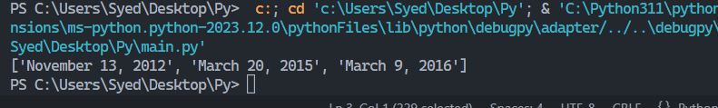

***Task 5***

***Store student’s data using nested dictionary.***

***Code***

students = {

    "student_one": {

        "name": "Sam",

        "age": 21,

        "grade": "A+"

    },

    "student_two": {

        "name": "Jungkook",

        "age": 20,

        "grade": "A"

    },

    "student_three": {

        "name": "Alex",

        "age": 22,

        "grade": "B+"

    }

}

print(students["student_one"]["name"])

print(students["student_two"]["age"])

print(students["student_three"]["grade"])

***OUTPUT***

